MATH COUNTS:
April is Mathematics Awareness Month, according to the American Mathematics Society and this year’s theme is Mathematics in sustainability. In light of this theme, Mathematics can especially be used to help prepare the nation’s youth to become a more energy-literate citizenry. Mathematics helps students understand complex energy problems and can be used in a wide range of fields to create solutions for a sustainable, energy-efficient way of life. For example, energy-efficiency can be seen in the following sub-categories of mathematics:
- Addition/Subtraction
  - An Energy Star Fridge uses 685 kWh of electricity a year and a non-Energy Star Fridge uses 1000 kWh of electricity a year. How much electricity would you save with an Energy Star Fridge?
- Multiplication/Division
  - If a computer uses 30 watts of electricity every hour how many watts will it use if you leave it on all day? How much electricity will it use if you remember to turn it off for 12 hours at night?
  - Pick an appliance that you use frequently and calculate the energy costs of your appliance usage with this formula:
Yearly cost =
Wattage rate of appliance $X$ $\frac{ 1 kW}{1000 W }(to convert to kw) X \frac{avg \# hours appliance is used }{year }$ X $\frac{cost*}{kWh}$

*The National Average cost per kWh is 12 cents, but you can contact your local utility to get your school’s actual price.
- Fractions
  - In many buildings up to 1/3 of the energy used by the buildings is wasted. If there are 22 classrooms in a school and 5 of them leave the lights on during recess, what fraction of the classrooms are wasting energy?
- Decimals
  - The school’s energy bill costs $1,125.85 per week. About how much would 3.5 weeks of energy cost?
- Algebra
  - Your company has 125 light bulbs, and you want to replace all of them with energy saving halogen light bulbs. Each 5 pack of halogen light bulbs costs $6.99. Assuming that you want to replace the 125 light bulbs in the building, how many packages should you buy and how much will it cost you? Let x be packages of light bulbs and y be the cost of the light bulbs.

- Graphs and Charts
  - What is the difference in savings between leaving the classroom lights on for 4 hours a day versus 7 hours a day?
  - In the graph below how much could Penndale save by turning only half the lights on instead of all the lights on?
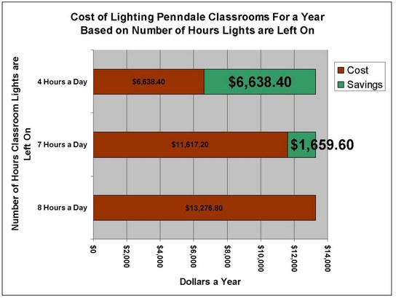
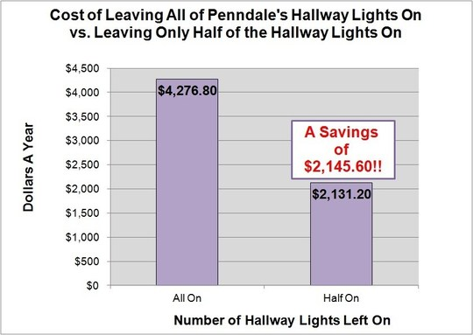

- Probability
  - Out of 200 customers in a neighborhood, the following table shows the average electric energy usage based upon the type of home an individual lives in:
Electric Usage in kWh
Type of Dwelling | <5,000 kWh | 5,000-7,000 kWh | 7,001-11,000 kWh | >11,000kWh | Total
Single Family | 15 | 35 | 65 | 25 | 140
Multi-Family | 25 | 15 | 15 | 5 | 60
Total | 40 | 50 | 80 | 30 | 200
The local utility company has decided to randomly select some customers to answer a survey.
- What is the probability of selecting someone who uses between 7,001 and 11,000 kWh?
- What is the probability of randomly selecting someone who uses less than 5,000 kWh and who lives in a multi-family dwelling?
- What is the probability of selecting someone who lives in a single family dwelling or uses between 5,000 and 7,000 kWh?
Interested in finding more about Mathematics in Sustainability, visit their web page: http://www.mathaware.org/index.html

